**Iniciar Sesión**

Main Page

Icon Account → ID = global-user-trigger

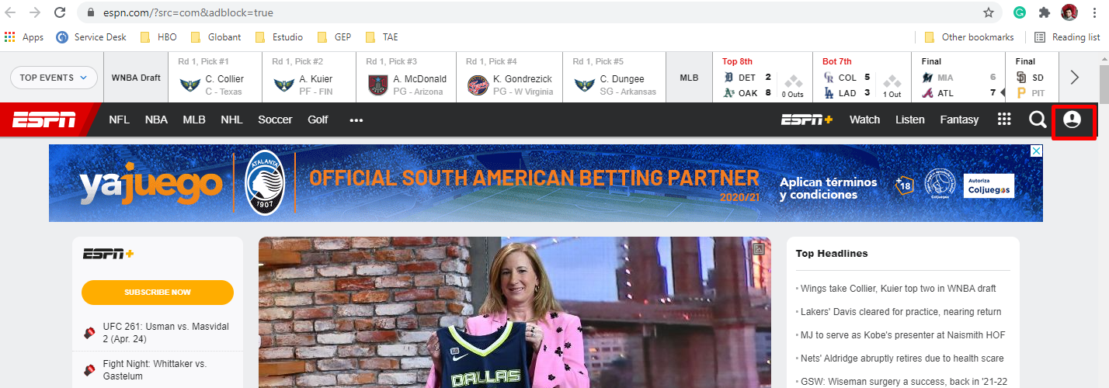

Account when user isn’t logged

li log In → CSS Selector = .account-management li:nth-child(7)

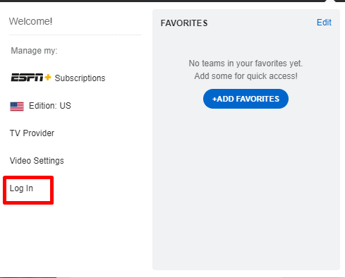

Iframe logIn

iFrameId → disneyid-iframe

inputEmail → .input-wrapper input[type=email]

inputPassword → .input-wrapper input[type=password]

btnLog In → button[aria-label='Log In']

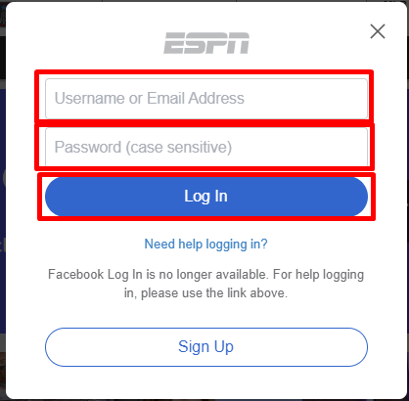

**Cerrar sesión**

Account with user logged

li logOut→ CSS Selector = .account-management li:nth-child(9)

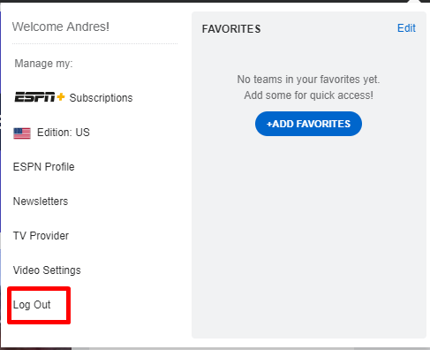

**Delete account**

li ESPN Profile→ CSS Selector .account-management li:nth-child(5)

Iframe Profile

iFrameId → disneyid-iframe

deleteOption → ID = cancel-account

